MILESTONE 4

CHECKOUT PROCESS MODULE

Tim A James

GCU | CST-236 DATABASE APPLICATIONS II | 3/22/21

# GITHUB REPO URLS

MILESTONE 4 REPO: https://github.com/tjames222/CST-236/tree/main/WEEK%203/MILESTONE%203

ECOMMERCE SITE REPO: <https://github.com/tjames222/CST-236/tree/main/EcommerceSite>

# WIREFRAMES

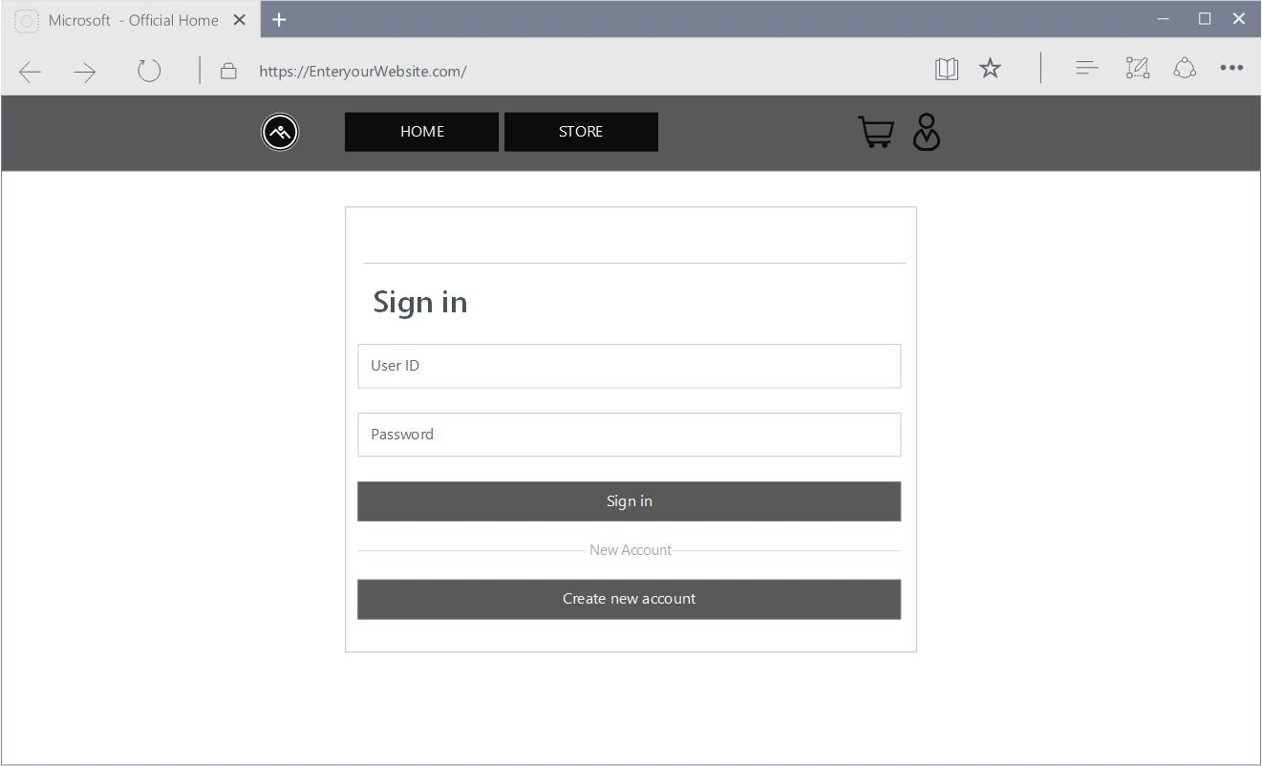Login Page.

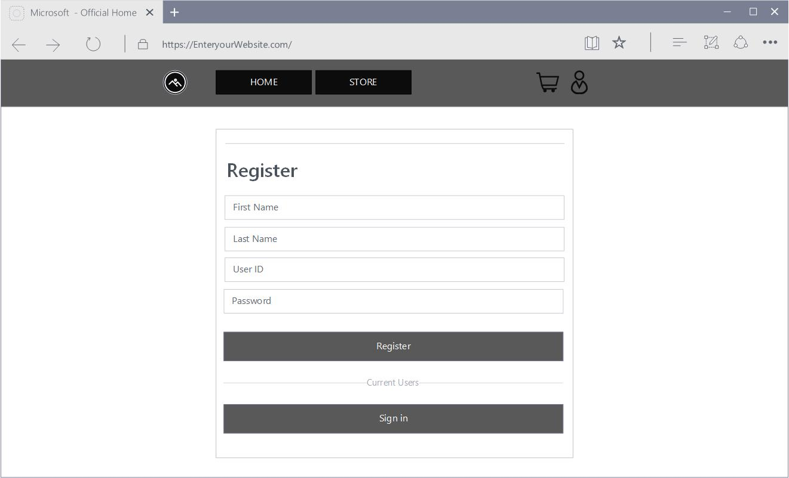Register page.

# ER DIAGRAM

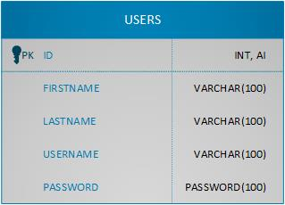Users ER diagram

# UML DIAGRAM

User Class UML Diagram.

# 

# DATA DICTIONARY

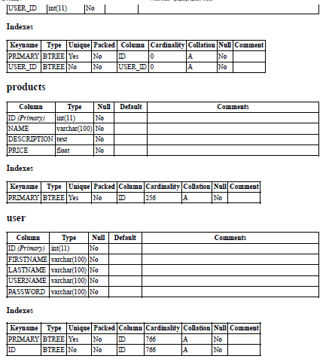

# ER DIAGRAMS PK FK Relations

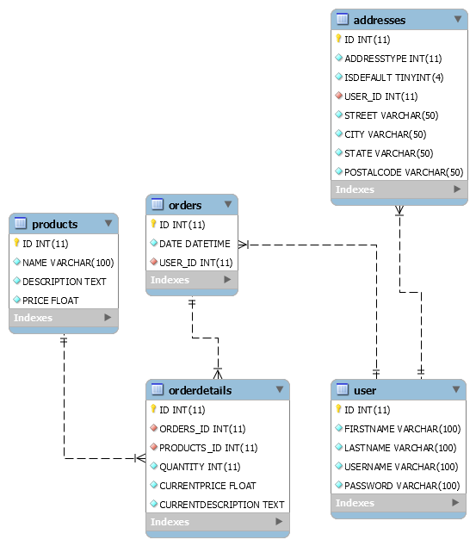

# SCREENCAST URL

https://www.loom.com/share/a32019d1b3654cb1bc6b97a0c06c9174